Infosys Springboard Virtual Internship 7.0 Completion Report

Team Details : FarmVerse Precision Agriculture Management Platform Group 1 Batch 1 – Team C .Team Members are Madhumitha G, Mohit Radhod, Mungara Naga Venkata Rama Chandram, P Koushal, Partheepan Sree Kavya, Yamuna.

Batch Number : 1
Start date : 29/06/2026
Names: Mungara Naga Venkata Rama Chandram
Internship Duration: 8 Weeks

1. Project Title
FarmVerse Precision Agriculture Management Platform Group 1

2. Project Objective
The main objective of the FarmVerse – Precision Agriculture Management Platform is to build a web-based system that enables farmers to manage their farms and agricultural activities in a digital format. The platform offers features for handling farms, crops, irrigation, fertilizers, user profiles, and agricultural reports.
The project seeks to minimize manual record-keeping, offer well-organized farm information, and simplify access to and management of agricultural data. It further provides role-based access, with separate views for Farmers and Administrators.

3. Project description in detail
FarmVerse is a full-stack web application built for managing farms and agricultural operations.
The project was developed using:
- Frontend: React.js
- Backend: Spring Boot
- Database: MySQL
- Authentication: JWT-based authentication
- API Testing: Postman
- UI Styling: Tailwind CSS
- Version Control: Git/GitHub
- Report Generation: PDF reports
Users can securely register and log in to the system. Farmers are able to manage their farms, crops, irrigation activities, and fertilizer records, while Administrators can view and manage system-level information.
The dashboard presents dynamic information, such as the number of farms and crops linked to the logged-in user. User identification is used throughout the system to ensure farmers can view only their own farm-related data.
The project holds real-world relevance, offering a digital platform for maintaining agricultural records and monitoring farm activities in a structured, organized way.

4. Timeline Overview
Week | Activities Planned | Activities Completed
Week 1 | Project introduction, requirement analysis, technology selection,  And project planning | Studied the FarmVerse requirements, modules, user roles, and overall project workflow
Week 2 | Develop basic backend structure | Set up Spring Boot backend, MySQL database and basic project structure
Week 3 | Develop landing page and  basic UI | Completed landing page, navigation, sidebar, top bar, and basic UI components
Week 4 | Implement authentication | Completed registration,  login, JWT authentication,  and Farmer/Admin role-based  access
Week 5 | Develop Farm and Crop CRUD operations | Completed Add, View, Update, and Delete operations for farms and crops and connected them with the database
Week 6 | Develop Irrigation and Fertilizer CRUD operations | Completed CRUD operations for irrigation and fertilizer management
Week 7 | API integration, API testing, report generation, and improvements | Integrated frontend with backend APIs, tested APIs using Postman, implemented report generation, dynamic dashboard cards, and error handling
Week 8 | Final testing, debugging, UI improvements, and documentation | Adding mail Notification Features .Completed final testing, fixed errors, improved responsive UI, verified modules, and prepared project documentation.

5a. Key Milestones
Milestone | Description | Date Achieved
Project Kickoff | Started the FarmVerse project and analyzed the requirements | Week 1
Prototype/First Draft | Completed the initial frontend and backend structure | Week 2–3
Mid-Term Review | Completed authentication, dashboard, and major management modules | Week 4
Final Submission | Completed major features, testing, and integration | Week 8
Presentation | Prepared the application demonstration and project documentation | Week 8

5b. Project execution details
The project was built using a frontend, backend, and database architecture.
The project began with an analysis of the requirements and database structure. The MySQL database was designed to store data related to users, farms, crops, irrigation records, fertilizer records, and reports.
The backend was developed using Spring Boot. REST APIs were built for authentication and management operations, and JWT authentication was implemented to securely identify logged-in users. Role-based access was also configured for Farmers and Administrators.
The frontend was developed using React.js. Key pages were implemented, including the landing page, login, registration, dashboard, profile, farm management, crop management, irrigation, fertilizer, and reports.
The frontend communicates with the Spring Boot backend via REST APIs, with data retrieved from and stored in the MySQL database.
The application was tested using Postman for backend API testing, and debugging was carried out by reviewing API responses, backend console logs, database records, and frontend errors.
Finally, the application was integrated and refined with a responsive UI, dynamic dashboard cards, tables, forms, navigation, error handling, and success messages.
Project Requirement Analysis
↓
System & Database Design
↓
Frontend & Backend Structure
↓
Database Implementation
↓
User Registration & Login
↓
JWT Authentication & Role Management
↓
Dashboard Implementation
↓
Farm Management
↓
Crop Management
↓
Irrigation Management
↓
Fertilizer Management
↓
Profile Management
↓
Report Generation
↓
Frontend–Backend Integration
↓
API Testing using Postman
↓
Debugging & Error Handling
↓
UI Improvements & Responsive Design
↓
Final Testing
↓
Project Completion & Documentation

6. Snapshots / Screenshots
FarmVerse Landing Page 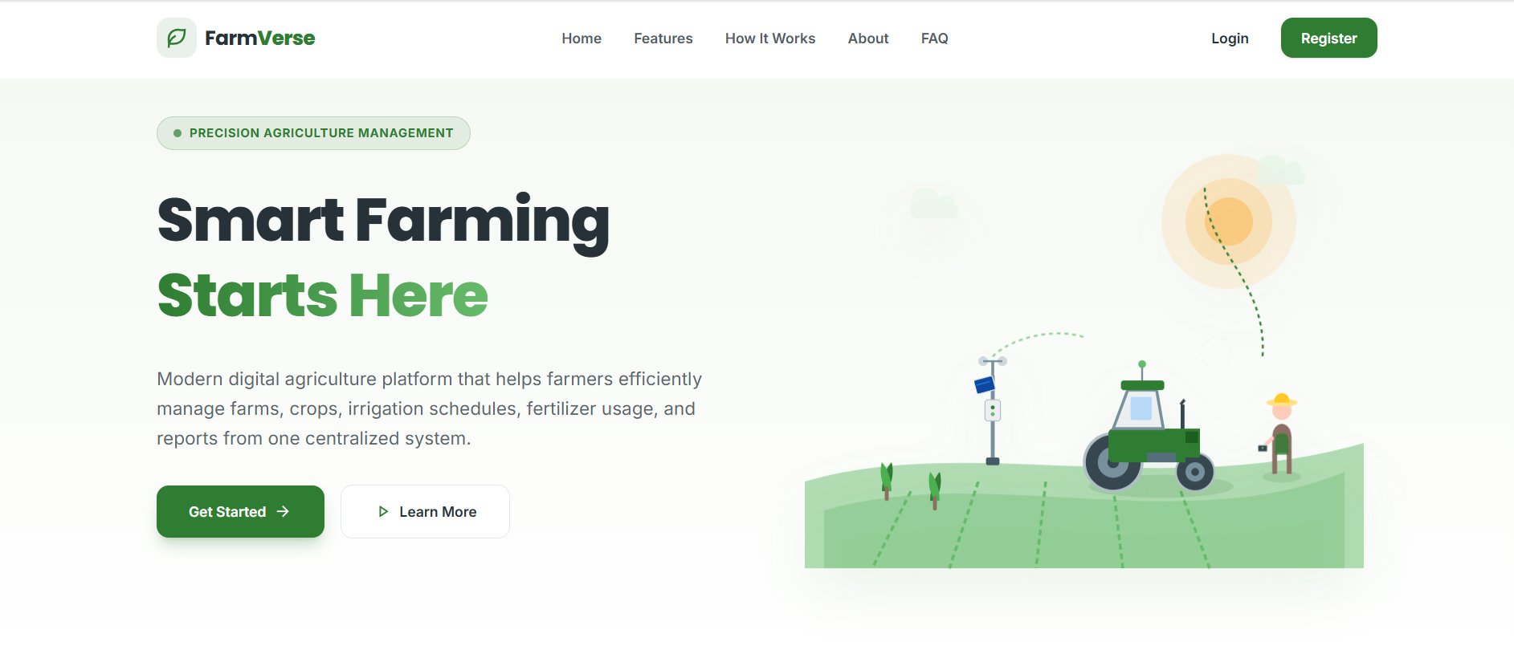
Authentication Flow
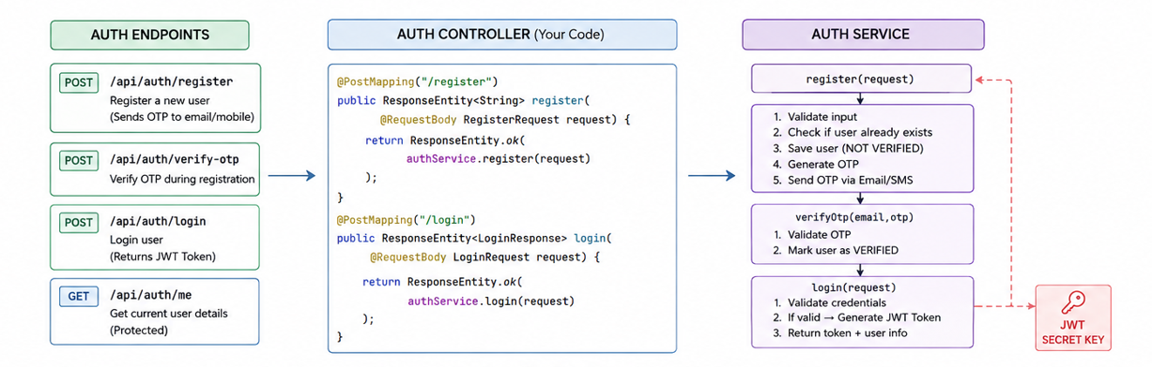
Farm CRUD Flow
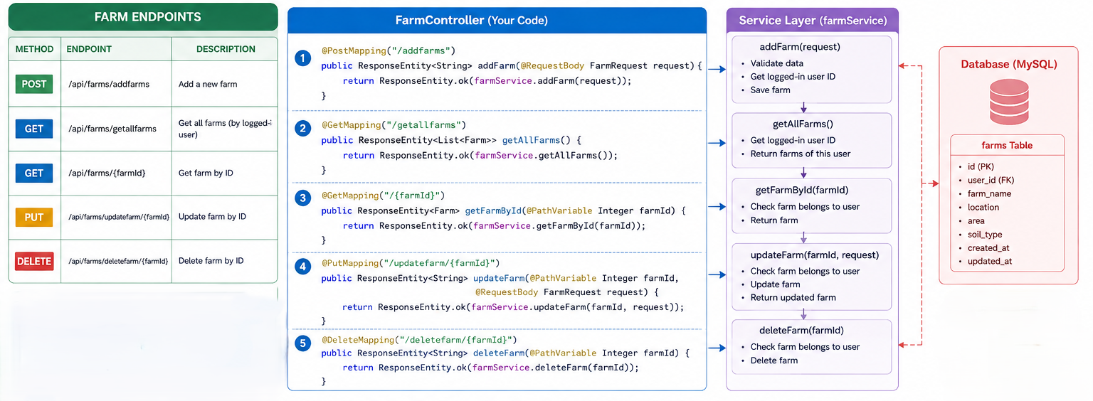

Add Farm Form
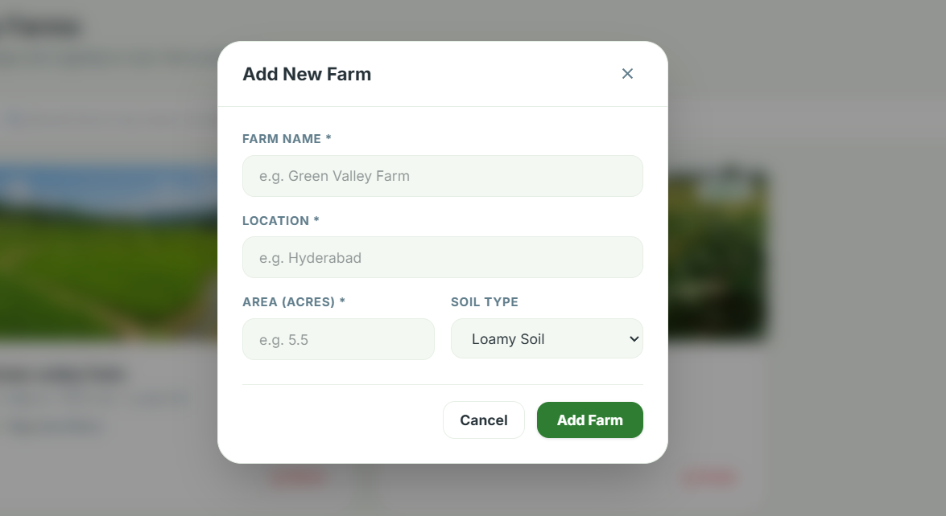
User Verification Status

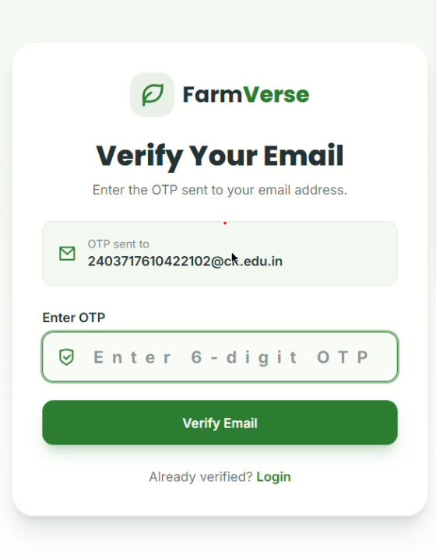

7. Challenges Faced
Several technical challenges arose during the course of the project.
Authentication and Authorization
Setting up JWT authentication and restricting access to protected pages for authenticated users only proved challenging.
Solution: JWT-based authentication together with Spring Security was configured to secure backend endpoints.
User-Specific Data
It was necessary to ensure that each farmer could access only their own farms and crops.
Solution: The authenticated user's ID was retrieved and used whenever farm-related data was fetched or added.
Frontend and Backend Integration
Linking React components to the Spring Boot REST APIs required careful handling of requests and responses.
Solution: Each API was first verified using Postman before being integrated into the React frontend.
API Errors
Errors such as 400 Bad Request and 403 Forbidden appeared during authentication and API testing.
Solution: These issues were resolved by examining backend logs, Postman responses, JWT tokens, and database records.
Dynamic Dashboard
The dashboard had to reflect information specific to the currently logged-in user.
Solution: This was achieved by fetching dashboard data dynamically from the backend rather than relying on fixed values.

8. Learnings & Skills Acquired
The internship helped in developing the following technical and professional skills:
Technical Skills
- React.js development
- Spring Boot development
- REST API development
- MySQL database management
- Spring Security
- JWT authentication
- CRUD operations
- API testing using Postman
- Git and GitHub
- Responsive UI development
- PDF report generation
- Frontend and backend integration
Professional Skills
- Problem solving
- Debugging
- Requirement analysis
- Project planning
- Documentation
- Time management
- Testing and validation
- Understanding real-world software development workflow

9. Testimonials from team
This internship offered valuable hands-on experience in building a full-stack web application. Working on the project deepened my understanding of how the frontend, backend, database, authentication, and APIs come together in a real-world system.
Building FarmVerse strengthened my technical knowledge along with my problem-solving and debugging abilities, and gave me a clearer understanding of software development practices and project execution.

10. Conclusion
The FarmVerse – Precision Agriculture Management Platform was successfully built as a full-stack web application for managing agricultural activities.
It includes user authentication, role-based access, a dashboard, farm management, crop management, irrigation management, fertilizer management, profile management, and report generation.
The internship provided practical experience in React.js, Spring Boot, MySQL, REST APIs, JWT authentication, and software testing.
Overall, the project helped bridge the gap between classroom learning and real-world software development, while providing valuable experience in developing, testing, debugging, and integrating a complete web application.

11. Acknowledgements
I sincerely thank the organization for giving me the opportunity to complete this internship and work on the FarmVerse – Precision Agriculture Management Platform.
I am grateful to my mentor, Vinay Prashant, and my team members for their guidance, support, feedback, and encouragement throughout the project.
I would also like to thank my institution and faculty members for their continuous support and academic guidance, which helped me successfully complete this internship.
The knowledge and hands-on experience gained through this internship will be valuable for my future academic and professional growth.

